Prerequisites -2

|  |  |
| --- | --- |
| Team ID | PNT2022TMID43975 |
| Prerequisite | Software-Python |

Python software:

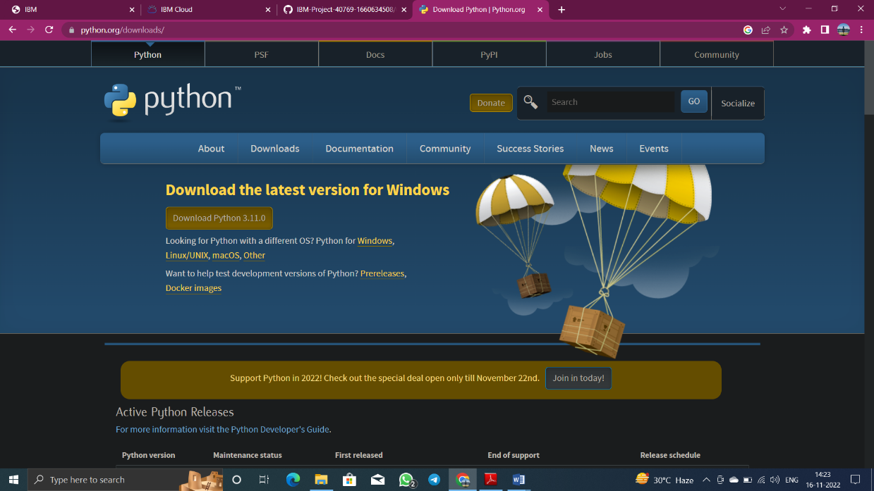

Python idle:

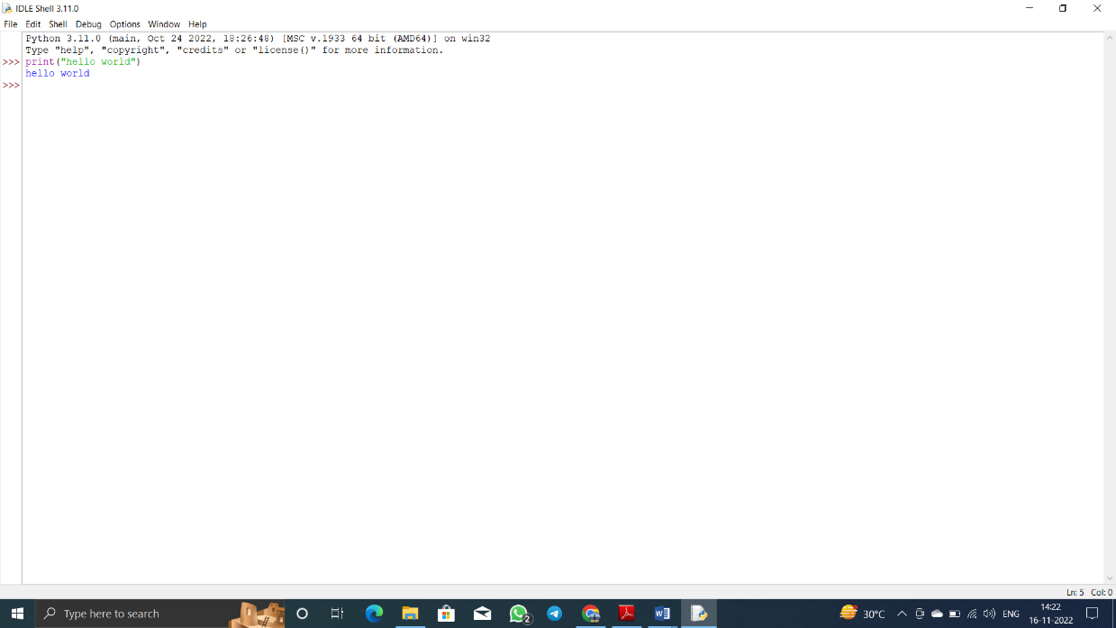

Python cmd:

